Finnish Home Recreation Calendar
July 2019
Sunday | Monday | Tuesday | Wednesday | Thursday | Friday | Saturday
 | 1 | 2 | 3 | 4 | 5 | 6
 | Happy Canada Day!  1:00- SCU Lory  2:00- Sing a long with Lory | 10:00- SCU/  Chair Dance  10:30- Word Games  1:00- Walks  2:15- Suomi Ryhma  3:00- Walks SCU | 10:00- SCU/  Fit and Fun  10:30- Witty Videos  1:00- Yard Outing  3:00- Sing a long  5:30- On the Road | BBQ Prep  10:00- Price is Right  1:00- Hans & Carlo | 12 noon  Family BBQ!  2:30- SCU Lory  3:10 Sing a long with Lory | Have a  Wonderful Day!
7 | 8 | 9 | 10 | 11 | 12 | 13
Have a Nice Day! | 10:00- SCU Exercises  10:30- Colouring  1:00- Yard Outing  3:00- Bowling | 10:00- SCU/  Chair Dance  10:30- Word Games  1:00- Walks  2:15- Suomi Ryhma  3:00- Walks SCU | 10:00- SCU  Fit and Fun  10:30- Witty Videos  1:00- Yard Outing  3:00- Sing a long  5:30- Reminiscing | 10:00- SCU/ Stretching  10:30- Rec Rack  1:00- Hans and Carlo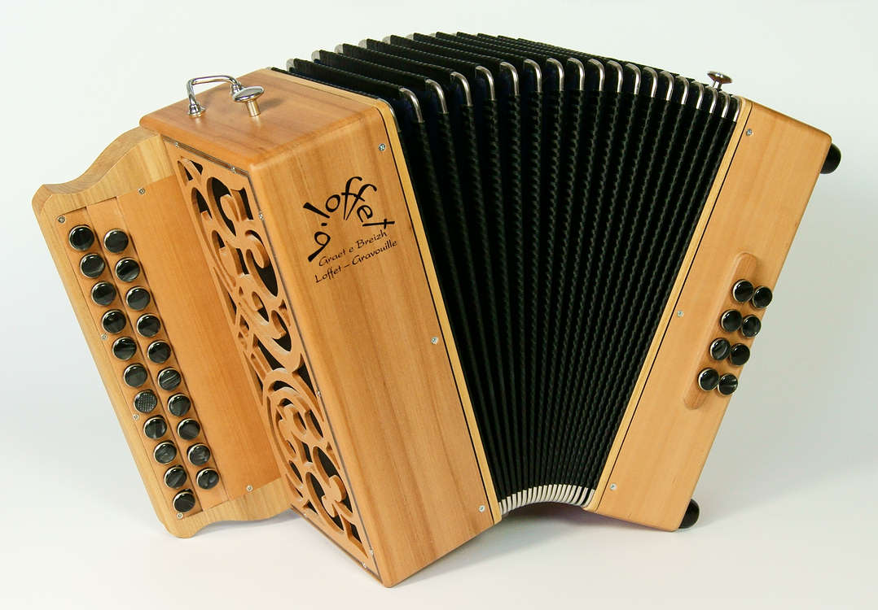  3:00- Bingo | 10:00- Games  1:15- Coffee Bar  2:30- SCU Lory  3:10- Sing a Long with Lory | 10:00- Fit and Fun  1:00- Raamattu Keskustelupiiri  3:00- 1 to 1 Visits
14 | 15 | 16 | 17 | 18 | 19 | 20
Have a Wonderful Day! | 10:00- SCU Exercises  10:30- Music Critique  1:00- Yard Outing  3:00- Piano and Song | 10:00- SCU/  Chair Dance  10:30- Word Games  1:00- Walks  2:15- Suomi Ryhma  3:00- Walks SCU | 10:00- SCU  Fit and Fun  12:00- Backyard BBQ  3:00- Sing a Long  5:30- Reminiscing | 10:00- SCU/ Stretching  10:30- Rec Rack  1:00- Hans and Carlo  3:00- Bingo  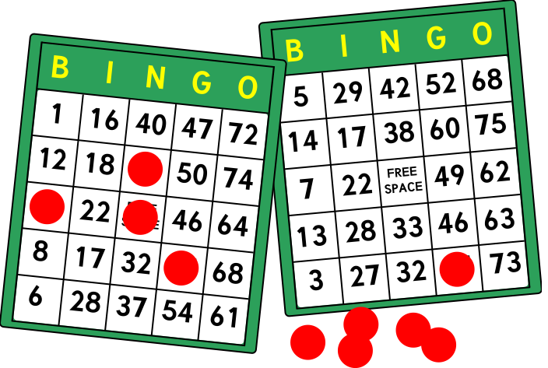 | 10:00- Games  1:15- Coffee Bar  2:30- SCU Lory  3:10- Sing a Long with Lory | Enjoy  Your Day!
21 | 22 | 23 | 24 | 25 | 26 | 27
1:00- Finnish Bethel Church | 10:00- SCU Exercises  10:30- Colouring  1:00- Yard Outing  3:00- Bowling | 10:00- SCU/  Chair Dance  10:30- Word Games  1:00- Walks  2:15- Suomi Ryhma  3:00- Walks SCU | 10:00- SCU  Fit and Fun  10:30- Witty Videos  1:00- Yard Outing  3:00- Sing a long  5:30- On the Road | 10:00- SCU/ Stretching  10:30- Rec Rack  1:00- Hans and Carlo  3:00- Bingo | 10:00- Games  1:15- Coffee Bar  2:30- SCU Lory  3:10- Sing a Long with Lory | Have a  Great Day!
28 | 29 | 30 | 31
Enjoy  Your Day! | 10:00- SCU Exercises  10:30- Colouring  1:00- Yard Outing  3:00- Bowling | 10:00- SCU/  Chair Dance  10:30- Word Games  2:15- Suomi Ryhma  3:00- Walks SCU | 10:00- SCU  Fit and Fun  10:30- Witty Videos  1:00- Yard Outing  3:00- Sing a long |  |  | Programs are subject to change. For more information please contact (604)325-8241.

